

Research Inclusion Strategy
2024-2029

Embedding Equality, Diversity and Inclusivity across the NIHR HealthTech Research Centre in Brain Injury

- Contact: Please provide the name and email of the staff member coordinating your Research Inclusion Strategy
James Piercy: Involvement & Engagement Lead (james.piercy@nhs.net)
Mita Brahmbhatt: Centre Manager (mita.brahmbhatt@nhs.net)

- Governance: Please outline where the Research Inclusion work sits in the governance structure and arrangements for the strategy
The Research Inclusion Strategy will be monitored by the core team with oversight from the Public Oversight Committee, to embed the governance principles set out across the HRC workforce, membership and public contributors. The CUH/BRC Leads for Research Inclusion will be invited to at least one POC meeting annually to review progress, with adhoc meetings as required to drive deliverables.

In addition, the Scientific Advisory Committee will advise the theme leads on the need to encourage and maintain diversity on the research teams and to monitor diversity of participants in research studies. Furthermore, the Management Committee will embed the Research Inclusion vision across the network of partner and collaborating organisations.

Progress against objectives and any changes to the strategy will be reported annually to NIHR, and align with national NIHR HRC Network workstreams in EDI.

See appendix 1: Organisation Structure and Partner Organisations.

- Vision: In the context of the objectives of your overarching award, please clearly state your vision for equality, diversity and inclusion and how it supports the delivery of the NIHR Research Inclusion Strategy 2022-27.
- Shared responsibility: Supporting EDI is not the work of a single person or organisation. Everybody in the organisation shares the duty to promote and enable Equality, Diversity and Inclusion.
- Partnership working: We know that we must work closely with individual, communities and organisations with diverse backgrounds and experience to embed inclusion.
- Training and support: We will offer training to support our staff to recognise and value diversity and implement procedures to support this through outreach initiatives.
- Monitoring: We will collect data on diversity and monitor this to identify areas which need improvement.
- Shared learning: We will regularly review our progress and processes and share our findings with partners and collaborators. We will look for best practice and learn from the experience of other regional and national groups.

- Objectives: Please clearly state what your equality, diversity and inclusion objectives are for the term of the award. There should be a clear follow through from vision -> objectives -> actions. Please use the Excel sheet to provide further detail in the accompanying action plan.
The HRC aims to support solutions that improve the quality of life of those affected and make these technologies accessible across the NHS.

Our goal in EDI is to seek to include those voices rarely heard in the research conversation. Through an inclusive research approach we can contribute new perspectives and creative solutions to the challenge in prevention, diagnosis and treatment of brain and spinal injury.

It is essential that a diverse community is included in the design and development process to ensure we develop technologies which address their unmet needs. We have a vision to reduce health inequalities by engaging with all sections of society.

Whilst our primary focus is on the 9 protected characteristics, we are aware that geographical location and socio-economic status are also determinants in the risk of brain and spinal injury. People affected by the conditions we investigate are also likely to have cognitive and communication impairments and we are aware that we must accommodate these in our work.

We aim to ensure that everybody’s voice is heard. In the HRC this means:
- NIHR Workforce - research fellows, clinicians and support staff
- NIHR Research workforce – partner organisations and teams supported by the HRC
- Advisors - industry partners, Technology evaluation and assessment teams
- Research participants - People recruited to studies
- Public contributors - Lay members Involved at each stage of the research cycle

Aims and objectives

We will focus on the following high level aims and align with the NIHR Research Inclusion Strategy (22-27):

- Embed inclusivity and diversity in all aspects of our work
- Monitor and record diversity of people of protected, and other relevant, characteristics

Current position

The Register for Healthcare Innovations and Technology Evaluation (RHITE) database gathers information about all those interested in contributing to HRC PPIE activity.

The current number of registrations is 66, with an aim to increase this to 100 by March 2025. The diversity of the group is given in Appendix I. We will use this database and national data on demographics affected by brain and spinal injury to identify gaps in diversity. We will begin by exploring geographical distribution especially areas close to partner organisations.

The RHITE list will be expanded to include information on research teams and industry collaborators in order that we can also monitor diversity and inclusion in the research workforce.

See appendix 2: Diversity of Patient Collaborators on RHITE Compared to 2021 Census Data
- Research Inclusion budget (if applicable): Please provide details of your equality, diversity and inclusion expenditure each year. Please separate out staffing and project costs.
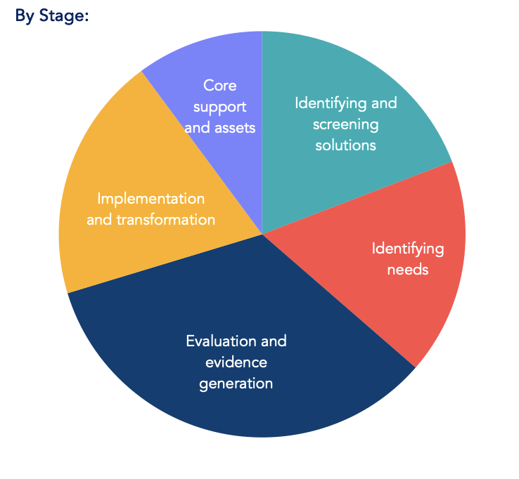
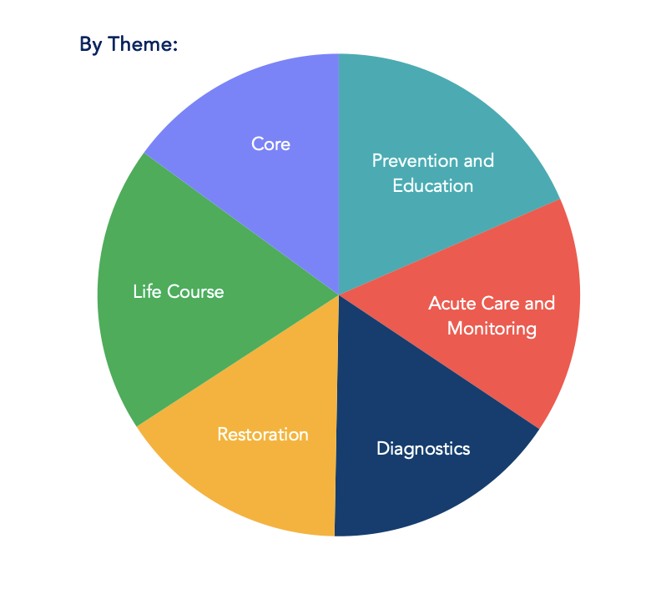
EDI costs have been embedded across 6 themes and will span the various initiatives and programmes across the HRC
- Collaboration: Please give details of planned collaborative inclusion activities with other parts of NIHR Infrastructure, wider NIHR and other partners (including industry).
We will work closely with partners, NIHR infrastructure and the HRC Network to identify and share best practice. Building trust in new communities takes time. We will use the networks established by the HRC partners across the country to enable us to reach new and engaged patient and public contributors. When gaps in representation are recognised we will approach community leaders and stakeholders in an attempt to engage with those groups.

We recognise the valuable work in research inclusion undertaken by the NIHR Cambridge Biomedical Research Centre and where our themes and priorities overlap, we will continue to work together to deliver improved inclusivity. The Research Delivery Network (formerly the Clinical Research Network) in East of England and the East of England PPIE collaborative have done good work establishing links with communities and we will employ their learning to reach underrepresented groups and to provide brain injury-related research participation and involvement opportunities to the communities they are working with. Furthermore, we will build on these principles to reach out across our network of partner organisations.

When recruiting to research roles, we will identify key people and organisations and target advertising.

Appendix 1: HRC Organisational Structure

 |  | 
 |  | 
 |  | 

Appendix 2: Diversity of Patient Collaborators on RHITE Compared to 2021 Census Data
Last updated: 23/09/2024

RHITE data:
2021 Census data for England and Wales:
RHITE data:

2021 Census data for England and Wales:

RHITE data:

2021 Census data for England and Wales:

RHITE data:
2021 Census data for England and Wales:

RHITE data:

2021 Census data for England and Wales:

RHITE data:
2021 Census data for England and Wales:

Breakdown of ethnic minority groups:
Ethnic group | 2021 Census Data | RHITE Data
Asian, Asian British or Asian Welsh: Bangladeshi | 1% | 2%
Asian, Asian British or Asian Welsh: Chinese | 1% | 0%
Asian, Asian British or Asian Welsh: Indian | 3% | 6%
Asian, Asian British or Asian Welsh: Pakistani | 3% | 0%
Asian, Asian British or Asian Welsh: Other Asian | 2% | 2%
Black, Black British, Black Welsh, Caribbean or African: African | 2% | 9%
Black, Black British, Black Welsh, Caribbean or African: Caribbean | 1% | 2%
Black, Black British, Black Welsh, Caribbean or African: Other Black | 0% | 0%
Mixed or Multiple ethnic groups: White and Asian | 1% | 0%
Mixed or Multiple ethnic groups: White and Black African | 0% | 3%
Mixed or Multiple ethnic groups: White and Black Caribbean | 1% | 0%
Mixed or Multiple ethnic groups: Other Mixed or Multiple ethnic groups | 1% | 5%
White: Irish | 1% | 2%
White: Gypsy or Irish Traveller | 0% | 0%
White: Roma | 0% | 2%
White: Other White | 6% | 9%
Other ethnic group: Arab | 1% | 0%
Other ethnic group: Any other ethnic group | 2% | 2%

Ethnic groups with no representation on RHITE:
- Asian/Asian British - Chinese
- Asian/Asian British - Other Asian
- Black/Black British - Other Black
- Mixed/Multiple ethnic groups - White and Asian
- Mixed/Multiple ethnic groups - White and Black Caribbean
- White - Gypsy or Irish Traveller

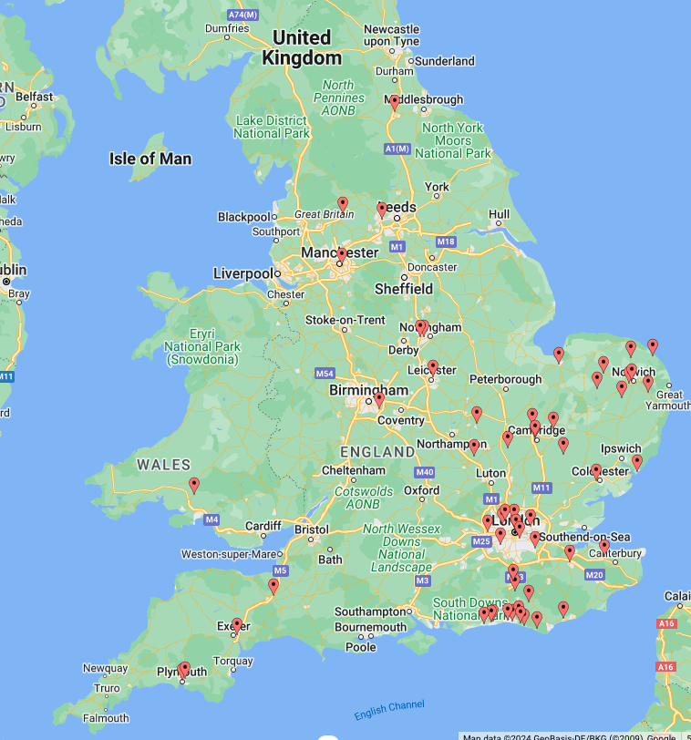

Location of patient contributors (Updated: 17/09/2024)

