**Patient and Public Involvement and Engagement Strategy**

**(2024-2029)**

*Our vision and priorities for collaborative working between*

*researchers, industry, and those with lived experience.*

# What you will find in this document:

 Who is this strategy for and what is its purpose? 3

 Context 3

 Values and Principles for involvement and engagement 4

 Governance 4

 The HRC team 5

 Our partners and collaborators 6

 Our aims and SMART objectives 6

Aim 1: Support involvement in Brain Injury HRC programmes through a diverse and inclusive panel of people with lived experience of brain and spinal injury. 7

Aim 2: Use insight of unmet need from those with lived experience to guide innovation and development of new technologies. 8

Aim 3: Raise awareness of brain and spinal injury, their impacts, and the role of research and technology in prevention, assessment and treatment. 8

Aim 4: Ensure public collaborators are rewarded fairly and recognised. 9

 Example PPI questions 9

 Evaluating our impact 10

 How this strategy was developed 10

 Words and acronyms used in this document 10

 Acknowledgements 11

 Appendix I – Public Oversight Committee: Terms of Reference 12

 Appendix II - Strategic partners 16

 Appendix III – Engagement ideas and opportunities 17

# Who is this strategy for and what is its purpose?

This strategy is for the NIHR HealthTech Research Centre in Brain Injury (Brain Injury HRC). It has been co-developed with our Patient Oversight Committee (POC) to set clear aims and objectives for the Patient and Public Involvement and Engagement programme (PPIE).

This strategy outlines how we intend to deliver and measure the impact of our PPIE work. It also provides information about our objectives and delivery plan.

This strategy is intended to be shared with current and future collaborators from research, industry, clinical practice and those with lived experience of brain and spinal injury.

# Context

More than 350,000 people are admitted to hospital every year in the UK with an acquired brain injury. This includes 158,000 with a traumatic brain injury and 137,000 with stroke.

There are around 2,500 new spinal cord injuries every year in the UK. New innovations and treatments are needed to improve outcomes for these people.

The Brain Injury HRC is one of fourteen nationally designated sites and is part of the HRC Network. This Network supports co-ordination across external agencies, dissemination of support and information, and community engagement.

#### What is Public Involvement and Engagement?

Involvement - Where members of the public are **actively** involved in research projects and/or organisations.

Examples of public involvement are:

1. A joint grant holder or co-applicant on a research project,
2. Involvement in identifying research priorities,
3. Commenting and developing patient information leaflets or other research materials,
4. Undertaking interviews with research participants,
5. User and/or carer researchers carrying out the research.

Engagement- Where information and knowledge about research is given and shared at public events.

Examples of engagement are:

1. Science festivals open to the public with debates and discussions on research,
2. Open days at a research centre where members of the public are invited to find out about research,
3. Raising awareness of research through media such as television programmes, newspapers and social media,
4. Dissemination to research participants, health and research colleagues or members of the public on the findings of a study.

Opportunities for Public Engagement can be found in Appendix III.

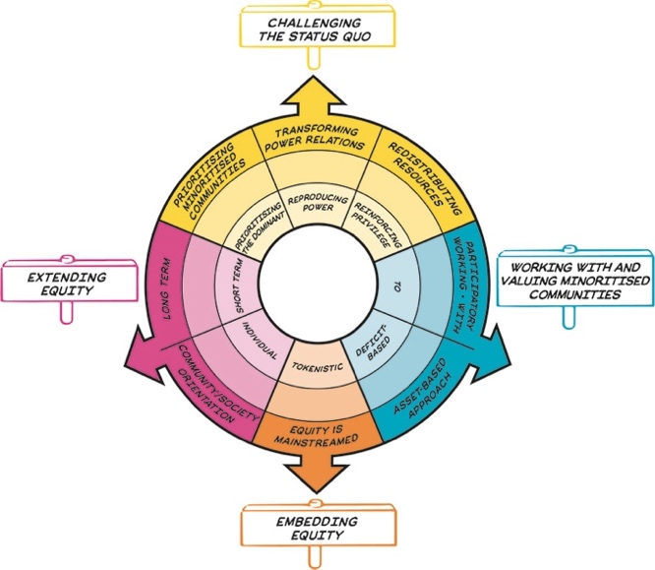

The Brain Injury HRC’s (2024-2029) approach to PPIE extends the principles established by the Brain Injury Healthcare Technology Co-operative (2013-2017) and MedTech Co-operative (2018-2024).

Embedding of PPIE will be done via clear aims and SMART objectives. These will be prevalent in all aspects of our activities and at every point of the research cycle.

These include:

1. The generation and validation of relevant unmet needs,
2. Review, evaluation, and feedback of solutions/innovations considered by us,
3. Co-design of research studies being developed through technology programmes or led by industry/academic partners,
4. Providing opportunities for individual research participation,
5. Involvement in governance.

# Values and Principles for involvement and engagement

The Brain Injury HRC puts patient experience at the heart of all our work. The voice of lived experience will inform every stage of the research cycle to make sure that the design and development of health technologies meet patient needs and improves outcomes.

By building a large diverse patient group on the RHITE platform, we will be able to draw on the personal lived experience of patients and careers to best inform our work. The diversity of the group we will be monitored in line with the Research Inclusion Strategy and aims to be representative of the communities affected by brain and spinal injury.

We will work according to the UK National standards for PPI to embed a meaningful approach. Our engagement work will have clearly defined messages and targeted audiences appropriate to each project.

We will use the [Equity Compass tool](https://www.ucl.ac.uk/ioe/file/22844) (see image) to reflect on our engagement practice to monitor Equality, Diversity and Inclusion and to make our work accessible.

# Governance

The development and delivery of the strategy will be monitored by the Patient Oversight Committee (POC).

The POC will actively encourage the involvement of patients, carers, members of the public, and charitable and community representation in all aspects and stages of our work programme, including as is appropriate:

* Contributing to the design PPIE programme,
* Management and prioritisation of the work programme,
* Planning and development of specific topics,
* Research activity,
* Interpretation of research findings as appropriate,
* Peer review,
* Monitoring progress,
* Evaluating and reviewing actual versus expected outcomes.

The terms of reference of the POC, and role profiles can be found in Appendix I

# The HRC team

|  |  |  |  |
| --- | --- | --- | --- |
|  | **Prof Peter Hutchinson**  Honorary Director  Professor of Neurosurgery | National brain and spinal injury research centre to open in Cambridge | **Dr Alexis Joannides**  Co-Director  Academic Consultant Neurosurgeon |
|  | **Ms Mita Brahmbhatt**  Centre Manager |  | **Ms Isabel Stewart**  Centre Co-ordinator |
|  | **Mr James Piercy**  PPIE Lead |  | **Communications Officer**  TBA  **Commercialisation and Regulatory expert**  TBA |

For more information about us, please visit our website – [www.brainhrc.org](http://www.brainhrc.org/)

The core team is ably supported by the POC

1. Mr Robert Runcie; Chair of the POC
2. Mrs Kavita Basi; Brain Haemorrhage survivor, Board of trustees Brain & Spine Foundation Charity.
3. Lay members connected to partner organisations, see details below.

# Our partners and collaborators

The HRC works closely with regional and national partners across the UK. Representatives from these are involved in the development and delivery of the Involvement and Engagement activities described in the strategy.

Our partner organisations include:

|  |  |  |
| --- | --- | --- |
|  |  |  |
|  |  |  |
|  |  |  |

Strategic Collaborators are listed in Appendix II

# Our aims and SMART objectives

The strategy has key aims, each with its own SMART objectives. The aims were developed by the POC with support from the core team. They provide measurable outcomes, with milestones to monitor the impact and success of the strategy. The objectives will be reviewed and updated every 12 months.

We will collaborate with partners and third sector organisations to reach under-represented groups to improve diversity and inclusion in all our work.

We will use the Patient Involvement in Research Impact Toolkit (PIRIT) to track and record learnings from our Involvement and Engagement activity.

## Aim 1: Support involvement in Brain Injury HRC programmes through a diverse and inclusive panel of people with lived experience of brain and spinal injury.

|  |  |  |
| --- | --- | --- |
| **Smart Objectives:** | | |
| Objective | Time period | Monitoring information |
| Recruit 100 patients and careers to RHITE by linking with partners and third sector spinal and brain injury organisations. | Short - by March 2025. | Periodically review numbers registered on RHITE. |
| Ask all research groups to clarify experience required from patients/carers and to be clear about their research needs. | Short – by March 2025 | Issue and collate researcher requirement forms. Monitor number received. |
| Run 6 outreach focus groups. | Short - by March 2025. | Use the PIRIT tracking tool to record events and diversity of attendees. |
| Recruit additional members to POC, through our strategic partners. | Short - by Nov 2024. | Record invitations, membership, and areas of interest and experience. |
| Connect with underrepresented communities to encourage participation. | Medium - by Mar 2026. | Use PIRIT to record the names of communities/groups contacted. Monitor RHITE sign up after contact with these groups. |
| Hold monthly meetings of the POC to monitor and inform PPIE activity. | Short - by March 2025. | Record meetings and actions on our internal database (the Hub). |
| Review and update RHITE membership. | Long - from Mar 2027. | Reporting of numbers and engagement of participants every 6 months. |
| Develop an inclusive interactive patient portal to increase engagement with the work of the HRC. | Short - by March 2025. | Record date of platform implementation and track user engagement dates. |

## Aim 2: Use insight of unmet need from those with lived experience to guide innovation and development of new technologies.

|  |  |  |
| --- | --- | --- |
| **Smart Objectives:** | | |
| **Objective** | **Time period** | **Monitoring information** |
| Develop a comprehensive Directory of Unmet Needs (DUN) through consultation with patient groups. | Short - by Apr 2025. | Review submissions, keep record of DUN. |
| Provide patient involvement in 5 Technology Assessment Programmes (TAPs). | Medium - by Mar 2026. | Record events and participants in the PIRIT tracking tool. |
| Provide patient involvement in 2 Technology evaluation Programmes (TEPs). | Short - by Mar 2025. | Record events and participants in the PIRIT tracking tool. |
| Use PPIE to inform responses to grant calls on diagnostic pathways. | Medium - by Mar 2026. | Record outcomes of enquiries from research groups. |
| Record impact of PPI. | Medium- Long by Mar 2027. | Researcher survey capture changes as a result of PPIE, 6 months after initial work. |

## Aim 3: Raise awareness of brain and spinal injury, their impacts, and the role of research and technology in prevention, assessment and treatment.

|  |  |  |
| --- | --- | --- |
| **Smart Objectives:** | | |
| **Objectives** | **Time period** | **Monitoring information** |
| Identify potential engagement opportunities and activity. | Short - by Oct 2024. | Produce and share list with partners. |
| Identify key messages and audiences in discussion with partners and POC. | Short - by Jan 2025. | Produce messages and record in update strategy. |
| Form a consensus on advocacy for change with those with lived experience to inform public engagement messages. | Medium - by March 2027 | Record PPI sessions in the PIRIT tracking tool. |
| Present work on all themes at public facing events twice a year. | Long - from Jan 2025. | Record events in an engagement tracking tool. Include audience metrics and response. |
| Develop engagement to build understanding of sensitivity and specificity. | Medium- by Jan 2027. | Record delivery of engagement and audiences. |

## Aim 4: Ensure public collaborators are rewarded fairly and recognised.

|  |  |  |
| --- | --- | --- |
| **Smart Objectives:** | | |
| **Objectives** | **Time period** | **Monitoring information** |
| Conduct a survey to find preferences for payment method and recognition. | Short- by Dec 2024. | Produce short report of responses. |
| Set clear reimbursement rates for each kind of involvement activity and update these in line with NIHR national standards. | Short - by Jan 2025. | Monitor payments to ensure standards are met. |
| Establish a system of payment via cheque or vouchers. | Short - by Nov 2024. | Record rates and mechanism. |
| Encourage partners to acknowledge lay contributions through authorship or public notice where appropriate. | Medium - by Mar 2025. | Add section to research team follow up to report to monitor acknowledgments. |

# Example PPI questions

Common questions for involvement activity have been identified below. These are likely to form part of multiple projects. Learning from these can be shared with other groups and inform the TAP and TEP.

1. What level of diagnostic accuracy is acceptable to patients and carers?

2. When should patients and career be approached about research?

3. How should patient information about research be provided?

4. Do levels of acceptance to new treatments and technologies vary between different communities?

# 

# Evaluating our impact

We will measure our success through the clear aims and objectives above set out above. We will annually review and update the SMART objectives in collaboration with the POC.

All our involvement activity will be tracked and reviewed. The Patient Involvement in Research Tracking Tool (PIRIT) will be used to monitor involvement and impact against the needs of research and industry teams to ensure that our work is in line with the UK Standards for Patient Involvement. To facilitate this, we have aligned our involvement database (RHITE) with PIRIT.

We will follow up all research groups we work with to see how involvement has informed their work and how well PPI has remained embedded in their projects. We will closely monitor the diversity of involved members and continually work to improve this. We will review our methodologies for involvement and measure success against the UK Standards for Patient Involvement.

Our engagement projects will have clear audiences and messages. We will conduct short evaluations of public and schools’ engagement to see if these have been achieved.

# How this strategy was developed

The strategy was developed with reference to the NIHR Strategic Commitments for Public Partnerships 2025-30. The development of the aims and objectives were subject to review by public contributors. The strategy was overseen and approved by the POC.

The strategy and SMART objectives will be subject to short, medium, and long term review. The POC will have oversight of this to monitor progress.

# Words and acronyms used in this document

|  |  |
| --- | --- |
| **DUN** | Directory of Unmet needs. This list is developed with patient involvement to identify areas where new technologies can make a meaningful contribution to prevention, treatment and recovery from injury. |
| **Engagement** | Ways in which research can be shared with and influenced by the public in a two-way process. Engagement encourages researchers to listen and interact with the general public, for example, via science festivals, open days, media coverage. |
| **Involvement** | Also known as PPI or public involvement. An active partnership between patients, the public and researchers in the research process, rather than the use of people as ‘subjects’ of research. For example, this might be working with research funders to prioritise research or offering advice as members of a project steering group. The term ‘public’ includes individuals (patients, potential patients, carers, and people who use health and social care services) as well as organisations that represent people who use services. |
| **Participation** | Taking part in a research project as a subject of research. Participants may try new innovations, medicines or placebos in order to test their efficacy in controlled trials. |
| **POC** | Public oversight committee. The group that led the development of this strategy and oversees its implementation. The group is chaired by and made up of people with lived experience of brain and spinal injury, supported by the Patient and Public Involvement and Engagement Lead. |
| **RHITE** | Register for Healthcare Involvement and Technology Evaluation. A database of people interested in becoming involved in research projects or acting as participants in studies. The database collects demographic information about people to monitor inclusivity and diversity in our panels. |
| **SMART objectives** | A method of describing activities in order to measure success of delivery. SMART objectives are Specific, Measurable. Achievable, Relevant and Time-bound. |
| **TAP** | Technology Assessment Programme. The programme run by the HRC assesses the feasibility of ideas through review by a clinical panel. An involvement group will also review proposals to check for suitability and how well they work towards unmet needs. |
| **TEP** | Technology Evaluation Programme. This extended programme run by the HRC will set up trials and use involvement to focus research questions. |

# Acknowledgements

In addition to the POC, thanks to the people who reviewed and assisted with the development of this strategy:

1. Dr. Amanda Stanks- PPIE Lead, NIHR Cambridge BRC
2. Mr Greg Dean- Public contributor
3. Mr Jeremy Dearling - Public contributor

# Appendix I – Public Oversight Committee: Terms of Reference

#### 

#### Purpose

To provide the governance policies for the NIHR HealthTech Research Centre in Brain Injury (Brain Injury HRC) Public Oversight Committee (POC). These align with relevant governance policies of its NIHR contract and Cambridge University Hospitals NHS Foundation Trust (CUH), on behalf of its partner organisations. The document outlines: lines of accountability, roles and responsibility, and key objectives and deliverables for its members. It should be read in conjunction with the Brain Injury HRC PPIE Strategy 2024-2029.

#### Context

The Brain Injury HRC is one of 14 nationally designated centres (2024-2029) and is part of the HRC Network. This Network supports co-ordination across external agencies, dissemination of support, and encourages community engagement.

The HRC approach to Patient and Public Involvement and Engagement (PPIE) and Equality, Diversity, and Inclusion (EDI) extends the principles established by the Brain Injury Healthcare Technology Co-operative (2013-2017) and MedTech Co-operative (2018-2024). Integration of PPIE will be done via our key objectives which will be prevalent in all aspects of HRC programme activities and at all points of the research cycle. These include:

1. the generation and validation of relevant unmet needs,
2. review, evaluation, and feedback of solutions/innovations considered by the HRC,
3. co-design of research studies being developed through its technology programmes or led by industry/academic partners,
4. providing opportunities for individual research participation,
5. involvement in HRC governance.

#### Scope

The POC will actively encourage the involvement of patients, carers, members of the public, charitable and community representation in all aspects and stages of the HRC work programme, including as is appropriate:

1. contributing to the design of PPI activity;
2. management and prioritisation of the work programme;
3. planning and development of specific topics;
4. research activity;
5. interpretation of research findings as appropriate;
6. peer review;
7. monitoring progress;
8. evaluating and reviewing actual versus expected outcomes.

#### Deliverables

The POC will:

1. Develop, monitor and review the PPIE & EDI strategy and action plans, maintaining alignment with NIHR and national strategies and priorities.
2. Provide PPIE clinical themes governance and facilitate PPIE for HealthTech Fellowship, technology programmes and, where applicable, supported-projects and collaboratives.
3. Oversee development, delivery and effectiveness of the outreach programme, Register for Healthcare Involvement & Technology Evaluation (RHITE) and the associated patient portal (HealthHub).
4. Establish a network of locality champions, including public contributors, community representatives and charitable organisations.
5. Capture the impact of the PPIE workstreams, including through Case Studies.

The POC will also provide annual reports with updates for all these areas.

#### Accountability

The POC is one of four committees that make up the Brain Injury HRC governance structure. The POC will be required to provide representation as required to the other 3 committees. The annual reporting cycle will be signed off by the Host Organisations (CUH) Research & Development Board on behalf of the Chief Executive Officer:

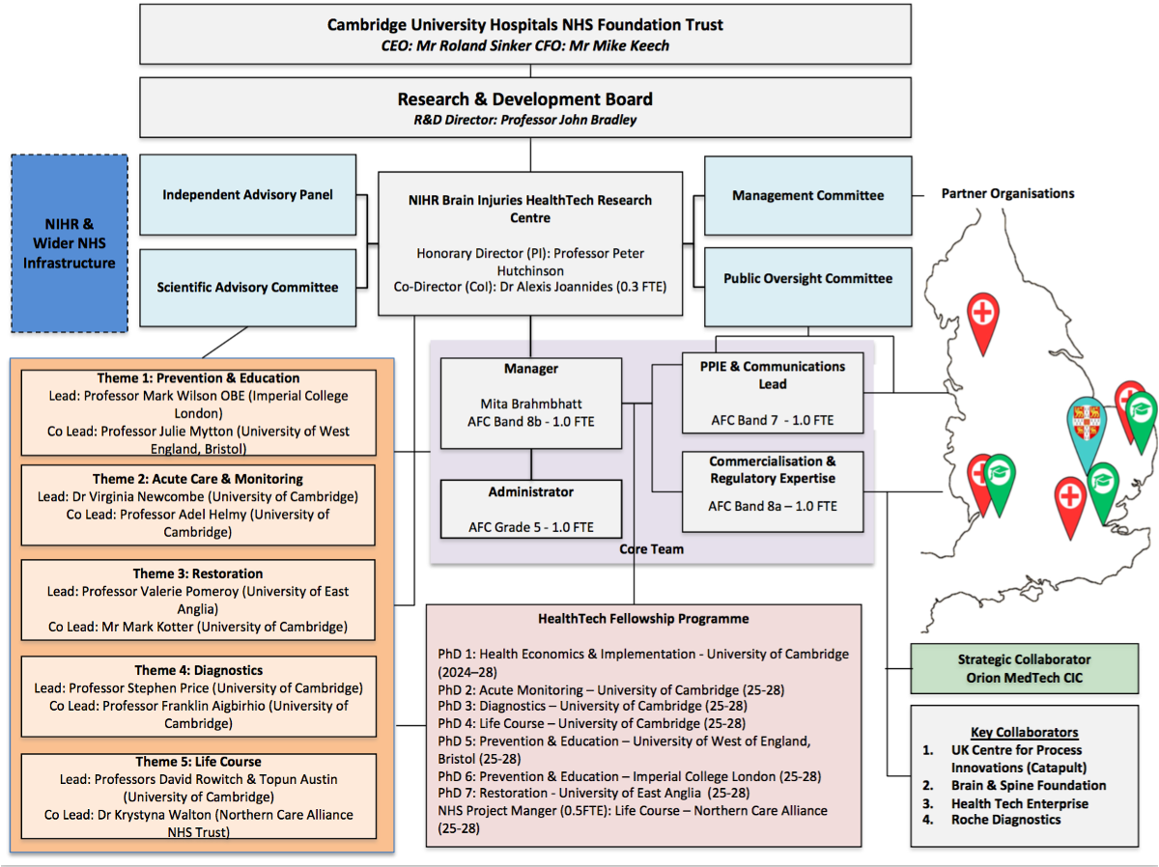

*Figure 1: HRC Governance Structure*

HRC Partners

*NHS Organisations*

Partner 1: Royal Papworth Hospitals NHS Foundation Trust (Lead)

Partner 2: University Hospitals Bristol and Weston NHS Foundation Trust

Partner 3: Imperial College Healthcare NHS Trust

Partner 4: Norfolk & Norwich University Hospitals NHS Foundation Trust

Partner 5: Northern Care Alliance NHS Foundation Trust

*Academic Institutions*

Partner 6: University of Cambridge

Partner 7: University of East Anglia

Partner 8: University of Essex

Partner 9: University of West of England, Bristol

#### Membership

The minimum membership for the POC will be:

1. Independent Chair Person: To be appointed (see appendix 1)
2. PPE Lead: Mr James Piercy
3. Public representatives from partner organisations with at least 5 localities represented (Manchester, Bristol, Norwich, Cambridge, London)
4. Co-opted Expertise:
   1. Charity representatives
   2. Community representatives
   3. HRC Network representatives
5. Core Team Representative: Delegated and as required

#### Values and principles

The POC will ensure PPIE representatives are valued and acknowledged. In no circumstance will representatives be out of pocket for PPIE activities, with public contributors’ payments made in line with the NIHR public payment guidance.

#### Escalation

Issues requiring escalation will promptly be raised with the Centre Manager.

#### Secretariat

The secretariat will be provided by the Core Team.

#### Confidentiality

All members, including co-opted attendance, are required to treat all matters as confidential and refrain from sharing discussions and documentation outside the confines of the committee. All external engagement, involving project related matters, should be discussed with the Core Team to ensure the correct agreements are in place. Where required, members will confirm in writing any requirements relating to confidentiality, Intellectual Property, Non-Disclosure and Collaboration Agreement.

#### Frequency of meeting

Monthly virtual meetings, ad-hoc meetings to be convened by the secretariat as required.

#### Tenure

POC members will remain in post for a minimum of 1 year. Membership will be reviewed annually and new members invited if gaps in representation are identified.

#### Review

This document will be reviewed annually in line with the PPIE strategy.

### Appendix 1 – Chair’s role Specification

Independent Chairperson for the NIHR HealthTech Research Centre in Brain Injury Public Oversight Committee

PPIE/EDI POC Chair role description

1. Agree agenda and chair monthly committee meeting
2. Respond to misc. requests from NIHR on PPIE/EDI
3. Respond to requests and support to HRC Brain Injury team
4. Represent HRC at regular Regional PPIE Collaborative network meetings
5. Represent HRC at regular National PPIE network meetings
6. Support national NIHR payments review group
7. Advise on HRC PPIE strategy development
8. Support adhoc national and regional network projects
9. Support misc. HRC research and adhoc projects
10. Support HRC Brain Injury conferences, workshops etc.
11. Time approx 2 to 3 days per month.

### Appendix 2 – Member’s role Specification

1. Attend monthly online meetings
2. Advise on HRC PPIE strategy development
3. Respond to misc. requests from NIHR on PPIE/EDI
4. Respond to requests and support to HRC Brain Injury team
5. Time approx 1 day per month

# Appendix II - Strategic partners

|  |  |  |
| --- | --- | --- |
|  |  |  |
|  |  |  |
|  |  | Inserting image... |
|  |  |  |

# Appendix III – Engagement ideas and opportunities

#### Opportunities for public engagement:

#### Festivals

There are several events close to HRC partners which could host talks and interactive stands:

|  |  |
| --- | --- |
| Half term Feb | [Norwich science festival](https://norwichsciencefestival.co.uk/) |
| Early March | [Bristol Neuroscience festival](https://www.bristol.ac.uk/neuroscience/bnf/) |
| Mid March | [Cambridge festival](https://www.festival.cam.ac.uk/) |
| Mid June | [Exhibition road festival](https://www.greatexhibitionroadfestival.co.uk/) |
| Half term Oct | [Manchester science festival](https://www.scienceandindustrymuseum.org.uk/manchester-science-festival) |

#### National events

There are national events that we might consider attending with other HRC groups:

|  |  |
| --- | --- |
| April | [Edinburgh science festival](https://www.edinburghscience.co.uk/festival/) |
| June | [Cheltenham science festival](https://www.cheltenhamfestivals.org/festivals/science-festival) |
| June | [Royal society summer exhibition](https://royalsociety.org/science-events-and-lectures/summer-science-exhibition/) |

#### Opportunities for Schools engagement:

|  |  |
| --- | --- |
| Autumn and spring term | [Education in action](https://educationinaction.org.uk/) - host talks for GCSE and A-level students, venues in London, Manchester, Warwick. |
| 7-16 March | [British science week](https://www.britishscienceweek.org/the-theme-for-2025-is-change-and-adapt/?gad_source=1&gbraid=0AAAAADQ5gb3xilk2U3TNrTct7qG-rZaTr&gclid=Cj0KCQjw2ou2BhCCARIsANAwM2G_tmaTEzqVH3wTByZEb1h7MEvA1NyM4KbILSX-KqNfFPiPDWVXW1MaAot6EALw_wcB) - National scheme for schools’ engagement. |
| Summer Term | [The Big Bang fair](https://www.thebigbang.org.uk/) - schools science fair held in Birmingham. |

#### Opportunities for Stakeholder engagement:

|  |  |
| --- | --- |
| November | [The UKABIF summit](https://ukabif.org.uk/page/Summit2024) brings together clinicians, researchers and innovators to talk brain injury. |
| June | The [Spinal injury association](https://spinal.co.uk/get-involved/events/rebuilding-lives/#:~:text=The%20aim%20of%20the%20Rebuilding,cord%20injury%2C%20post%2Dinjury.) run an annual conference. |

#### Engagement ideas:

Schools and festivals are broadly interested in 3 kinds of activity. There is potential for all of these within the remit of the HRC.

#### Talks

Interactive talks linked to our themes could be developed for different age groups. Talks would likely draw on topics from across the themes and use personal case studies:

|  |  |
| --- | --- |
| Prevention and Education | What are the main causes of brain and spinal injury?  What happens to the body and what are the results of injury What technologies and behaviours can reduce risk? |
| Acute Care and Monitoring | How are people treated in the early stages of injury?  Neurosurgery and the approaches used to minimize secondary injury.  Craniectomy vs cranioplasty, what is the difference? |
| Diagnostics | What imaging and bio marker technologies are used to make diagnosis and prognosis after injury?  Prediction of outcomes of mild TBI and the missing millions. |
| Restoration and Rehabilitation | Principles of rehabilitation.  Assessment of neurocognitive recovery.  How personalised treatments are created. |
| Life Course | Different types of problems experienced at the extremities of age.  How are these monitored and treated.  Next generation technologies to assist recovery. |

#### Workshops

Practical workshop activities aimed at different age groups. Participants problem solve and develop ideas to explore topics from the themes.

Examples:

1. Design a new kind of cycle helmet for young children
2. [Build and test a spine](https://bold.beam.vt.edu/Activities.html)

#### Hands-on activities

Short interactive activities led by students and researchers act as hooks for longer discussions about the work of HRC.

Examples:

1. VR cranioplasty
2. Try surgical tools on models
3. VR rehab apps, try rehab tasks with an eye covered or with non-dominant hand
4. Show case new tech

#### Engagement through other media:

Examples:

1. RHITE newsletter:
2. Updates on previous projects, what stage are ideas at?
3. Upcoming opportunities for involvement
4. Intro to researchers and projects from partners
5. Podcasts or vlogs
6. Conversations with theme leads about work
7. Conversations with media channels for broader dissemination
8. Blogs and articles
9. Submit pieces about HRC and work to other groups publications. e.g Neurotimes, Headways news, spinal injury association.

**Document Control**

|  |  |  |  |  |
| --- | --- | --- | --- | --- |
| **Title** | Patient and Public Involvement & Engagement Strategy (2024-2029) | | | |
| **Description** | NIHR HealthTech Research Centre in Brain Injury | | | |
| **Created By** | James Piercy, PPIE Lead (JMP) | | | |
| **Date Created** | 1 October 2024 | | | |
| **Maintained By** | Isabel Stewart, Centre Co-ordinator (IS) | | | |
| **Version Number** | **Modified By** | **Modifications Made** | **Date Modified** | **Status** |
| V0.1 | JMP | First Draft | 05.08.24 | Draft |
| V0.2 | JMP | Core Team review (1) | 12.08.24 | Draft |
| V0.3 | JMP | POC virtual review | 11.09.24 | Draft |
| V0.4 | JMP | BRC PPIE Lead review | 13.09.24 | Draft |
| V0.5 | JMP | Public Panel review | 17.09.24 | Draft |
| V0.6 | JMP | Core Team review (2) | 23.09.24 | Final Draft |
| V0.7 | JMP | POC finalisation | 26.09.24 | Submitted |